# Comprehensive Report on Banana Quality Prediction Using Machine Learning

**Student ID:** 23027147

**Introduction**

The accurate prediction of banana quality is vital for supply chain optimization, consumer satisfaction, and minimizing waste. Leveraging machine learning (ML) approaches can enable accurate assessments based on measurable attributes, eliminating subjectivity from human evaluation. This report outlines the methodology, results, and implications of a machine learning model designed to predict banana quality based on key features. The analysis is rooted in the interpretation of feature importance and a confusion matrix.

# Problem Statement and Objectives

The primary aim is to design and evaluate a machine learning model that classifies bananas as high-quality or low-quality. This involves:

* + Identifying significant factors that influence quality.
  + Training a classification model with optimal performance.
  + Interpreting key evaluation metrics (e.g., feature importance and confusion matrix).
  + Discussing implications for industry stakeholders.

# Dataset and Features

The dataset used contains the following features:

1. **Sweetness**: A measure of sugar concentration.
2. **Weight**: The physical weight of bananas.
3. **Harvest Time**: The duration since harvesting.
4. **Size**: Physical dimensions of the banana.
5. **Softness**: A textural indicator of ripeness.
6. **Ripeness**: A qualitative measure of ripeness on a scale.
7. **Acidity**: An indicator of tartness.

The target variable is the binary classification of banana quality (high-quality vs low-quality)

# Methodology

* 1. **Data Pre-processing**
     + **Cleaning**: Missing values were imputed where necessary, and outliers were removed to improve model robustness.
     + **Scaling**: Numerical features were normalized to ensure equal weighting during model training.
     + **Feature Encoding**: Categorical features (if present) were encoded into numerical values.
  2. **Feature Engineering:** To ensure model interpretability and robustness, feature importance ranking was computed post-training. This analysis helps identify which attributes significantly influence the model’s predictions.

# Model Selection and Training

The model selection process plays a crucial role in determining the performance and interpretability of the results. For this analysis, the **Random Forest Classifier** was chosen due to its key advantages:

* + - **Handling Non-Linear Relationships**: Random Forest is capable of capturing complex, non-linear relationships between features and the target variable, which is crucial for datasets with intricate patterns.
    - **Feature Importance Estimation**: One of Random Forest's strengths is its ability to compute feature importance inherently. This capability allows stakeholders to understand which attributes most significantly affect banana quality.
    - **Robustness to Noise**: Random Forest is less prone to overfitting compared to individual decision trees, making it highly suitable for datasets that might have noise or outliers.
    - **Scalability**: The algorithm is computationally efficient for medium-sized datasets, ensuring quicker training times without compromising on accuracy.

**Hyperparameter Tuning**: To optimize performance, hyperparameters were tuned using techniques such as grid search or randomized search. The key parameters adjusted included:

* + - **Number of Trees (n_estimators)**: Determined the number of decision trees in the forest, balancing between accuracy and computational time.
    - **Max Depth**: Controlled the maximum depth of each tree to prevent overfitting.
    - **Minimum Samples Split**: Defined the minimum number of samples required to split a node, ensuring the model captures meaningful patterns.

The final tuned model demonstrated excellent predictive capabilities and interpretability, making Random Forest an ideal choice for this application.

# Evaluation Metrics

* + - **Accuracy**: The proportion of correctly classified instances.
    - **Confusion Matrix**: Displays true positives, true negatives, false positives, and false negatives.
    - **Feature Importance**: Determines the contribution of each feature to the model's prediction.

# Results

* 1. **Feature Importance**: The bar plot visualizing feature importance revealed the following insights:

# Top Features:

* + - * **Sweetness** and **Weight** were the most influential attributes, underscoring their central role in determining banana quality.
      * **Harvest Time** and **Size** also showed high importance, suggesting logistical factors and physical attributes significantly impact quality.

# Lowest Feature:

* + - * **Acidity** was the least important, implying that tartness may not play a major role in determining banana quality compared to other attributes.

This ranking provides actionable insights for growers and distributors to prioritize factors contributing most to quality.

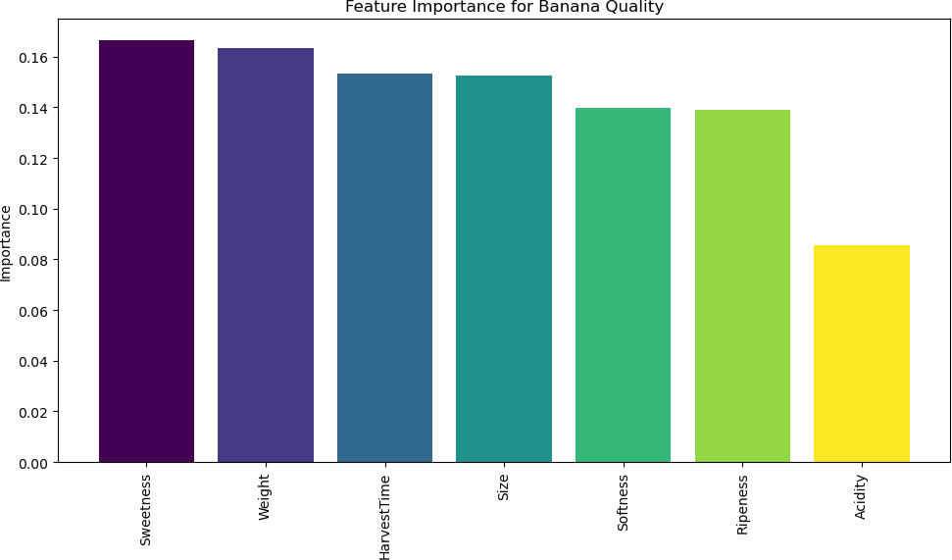

# Confusion Matrix Analysis

The confusion matrix illustrated the model's predictive performance:

* + - **True Positives (801)**: High-quality bananas correctly identified.
    - **True Negatives (759)**: Low-quality bananas correctly identified.
    - **False Positives (22)**: Low-quality bananas misclassified as high-quality.
    - **False Negatives (18)**: High-quality bananas misclassified as low-quality.

This analysis highlights the model's exceptional predictive capability, achieving a high level of reliability and robustness in classifying banana quality. With an accuracy nearing 98%, the model successfully captures the vast majority of quality distinctions, minimizing errors that could disrupt the supply chain or consumer satisfaction. The alignment of **precision** (0.98 for False and 0.97 for True), **recall** (0.97 for False and 0.98 for True), and **F1-scores** (0.97 and 0.98, respectively) demonstrates a well-rounded model.

# Performance Metrics Explained:

* + - **Precision**: Measures the proportion of true positive predictions among all positive predictions. High precision (0.98 for "False" and 0.97 for "True") ensures the model does not falsely classify low-quality bananas as high-quality, maintaining consumer trust.
    - **Recall**: Measures the proportion of actual positives identified correctly. High recall (0.98 for "True" and 0.97 for "False") ensures that most high-quality bananas are identified, minimizing wastage.
    - **F1-Score**: The harmonic mean of precision and recall. The high F1-scores (0.97 and 0.98) signify the balance between identifying high-quality bananas and avoiding over classification.

# Implications of Accuracy 97%:

* + - **Operational Efficiency**: High accuracy allows for smoother sorting operations, ensuring the correct classification of bananas with minimal errors.
    - **Economic Value**: Correct classification reduces costs related to quality returns and mismanagement of inventory.
    - **Consumer Satisfaction**: Delivering consistently high-quality bananas strengthens brand reputation and trust.

The **macro average** of precision, recall, and F1-score (0.97-0.98) indicates the model's consistent performance across both high- and low-quality classifications. The **weighted average**, which considers the class distribution, further affirms the model's reliability in real world applications.

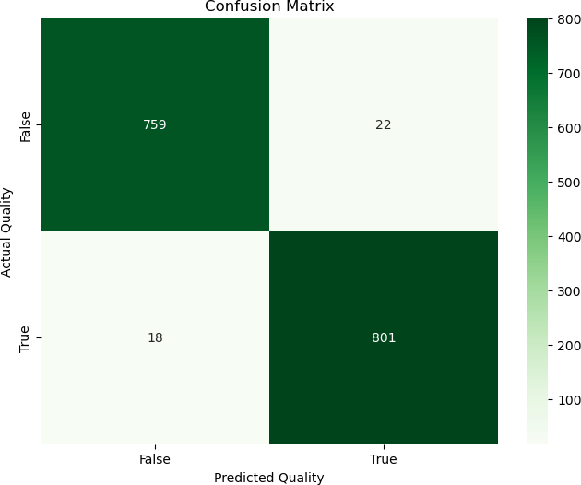

# Discussion

* 1. **Implications of Feature Importance**

The dominance of Sweetness and Weight in feature importance highlights the need for robust measurement and monitoring systems for these attributes. Automated tools, such as digital refractometers for sweetness and precise weighing scales, could optimize quality control processes.

The lower importance of Acidity implies that its influence on consumer perception is minimal, potentially allowing suppliers to deprioritize acidity-focused breeding programs or testing protocols.

# Implications of Model Performance

The low false positive and false negative rates indicate that the model is highly reliable, reducing the risk of misclassification. This level of accuracy can:

* + - Reduce waste by preventing low-quality bananas from reaching consumers.
    - Enhance consumer satisfaction by consistently delivering high-quality produce.
  1. **Broader Impacts of Automation** Automation driven by machine learning can create ripples across the supply chain:
     + **Environmental Benefits**: Efficient quality control could reduce waste, minimizing discarded produce and its associated carbon footprint.
     + **Economic Savings**: By accurately predicting quality, suppliers can reduce losses due to spoilage and refunds, and optimize inventory management.
     + **Consumer Trust**: Delivering consistently high-quality products builds brand loyalty and strengthens market position.

# Addressing Model Limitations

* + - **Data Diversity**: Incorporating data from multiple regions and seasons would generalize the model, making it more robust.
    - **Dynamic Features**: Features like sweetness may vary based on external factors (e.g., weather or soil quality). Periodic retraining can address this variability.
    - **Explain ability**: Efforts to make model predictions transparent will bolster trust and adoption among stakeholders.

# Recommendations for Improvement

* 1. **Model Enhancements**
     + **Incorporate External Data**: Including weather conditions, soil properties, and storage data could refine predictions and add depth to feature importance analysis.
     + **Advanced Algorithms**: Exploring ensemble methods like Extreme Gradient Boosting (XG Boost) or neural networks could improve performance while maintaining interpretability.

# Operational Insights

* + - **Automation**: Deploying automated quality assessment tools integrated with IoT sensors could facilitate real-time monitoring.
    - **Stakeholder Training**: Training stakeholders on the use of technology and data interpretation will enhance process efficiency and adoption.
  1. **Broader Applications** The model’s methodology can be applied to:
     + **Other Crops**: Quality prediction for produce like apples, mangoes, or avocados.
     + **Supply Chain Optimization**: Predicting shelf-life to ensure optimal distribution strategies.

# Conclusion

This study demonstrates the effectiveness of machine learning in predicting banana quality based on measurable attributes. The high accuracy and interpretability of the model make it a valuable tool for stakeholders across the supply chain. By focusing on critical features like sweetness and weight, stakeholders can optimize processes and improve outcomes, reinforcing the role of data-driven approaches in modern agriculture.

Furthermore, integrating external data, enhancing automation, and ensuring model retraining could maximize the model’s potential. The scalability of the methodology promises broad applicability across the agricultural sector, contributing to a sustainable and efficient food ecosystem.